

**Faculty of engineering - Shoubra**

**Benha University**

# Research Article / Research Project / Literature Review

in fulfillment of the requirements of

|  |  |
| --- | --- |
| **Department** | **Engineering Mathematics and Physics** |
| **Division** |  |
| **Academic Year** | **2019-2020 Preparatory** |
| **Course name** | **Computer** |
| **Course code** | **ECE001** |

## Title: -

**Build a website on Artificial Intelligence**

By:

|  |  |  |  |
| --- | --- | --- | --- |
|  | Name | Edu mail | B.N |
| 1 | Rahma Ahmed Abdelsalam | rahma195377@feng.bu.edu.eg | 344 |

**Approved by:**

|  |  |
| --- | --- |
| Examiners committee | Signature |
| Dr Ahmed Bayoumi |  |
| Dr Shady Elmashad |  |
| Dr Abdelhamid Attaby |  |

# Research objectives

The aim of my report is to create a website about artificial intelligence which conains tables,images,and lists.

# Table of contents

Divide your research into sections or subjects, mention each section first page at this

table

|  |  |
| --- | --- |
| **Subject / section** | **Page** |
| **Importance of Artificial Intelligence** | **3-4** |
| **Screenshots of my webpages** | **4-6** |
| **Source code** | **7** |
| **Conclusion** | **8** |
| **References** | **9** |

# Literature Review

* The importance of artificial intelligence and its subsequent components have been known for quite a long time now. They are being looked upon as tools and techniques to make this world a better place.  And it’s just not that you have to go to these fancy tech gadgets to be able to use them. You can simply look around and I am pretty much sure most of your tasks are made smooth by the use of artificial intelligence.
* Its importance lies in making our lives easier. These technologies are a great asset to humans and therefore are programmed to reduce the human effort as much as possible. They tend to possess the capability of working in an automated fashion and therefore manual intervention is the least thing which could be asked for or seen while operating parts associated with this technology.
* These machines tend to speed up your tasks and processes along with a guaranteed level of precision and accuracy and therefore this is what makes them a useful and important tool. Apart from making the world an error-free place by their simple and everyday techniques, these technologies and applications are not only related to our general and everyday lives. It is also impacting and holds importance for other domains as well.

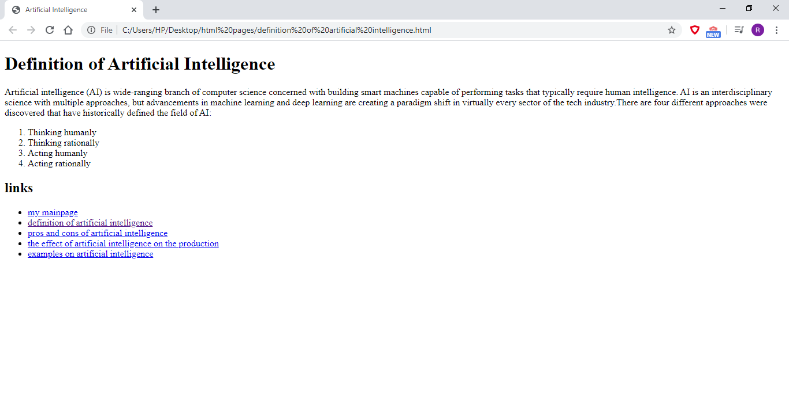***Screenshots :***

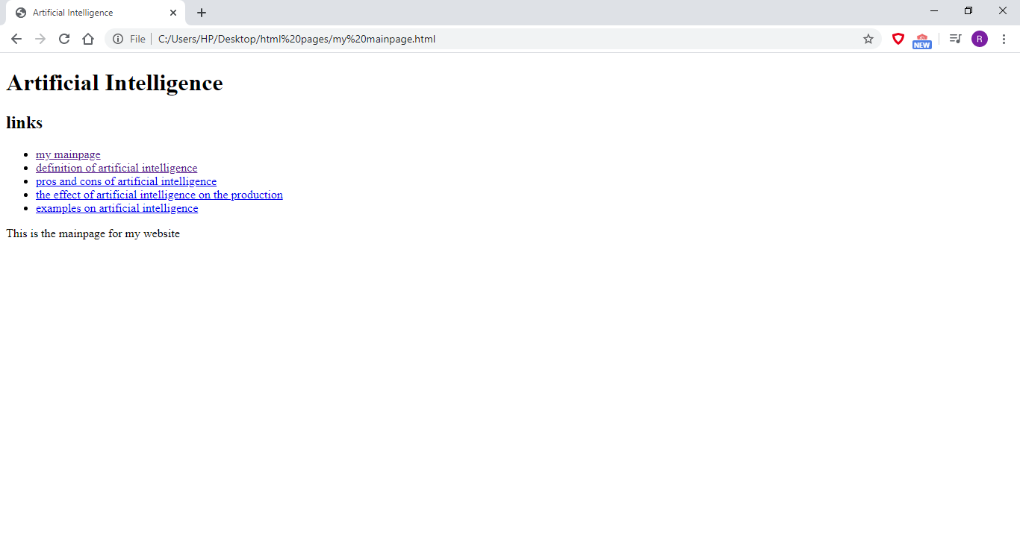

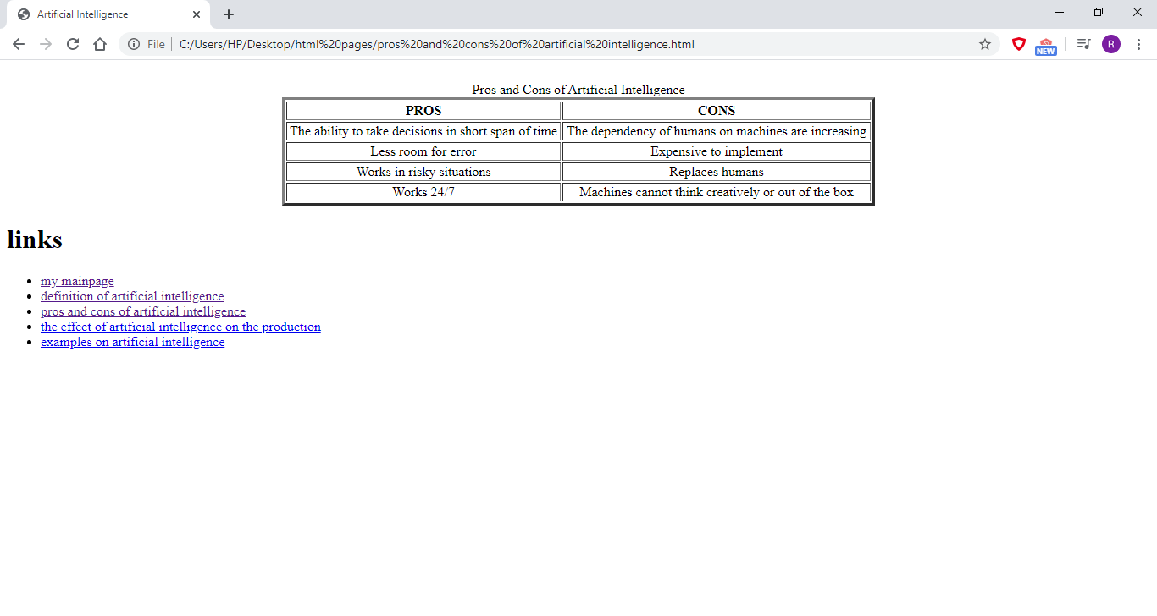

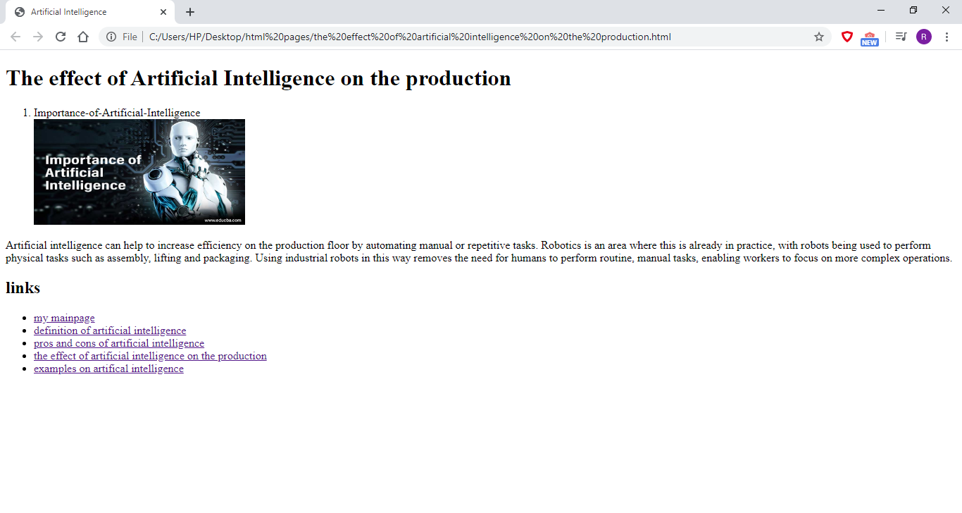

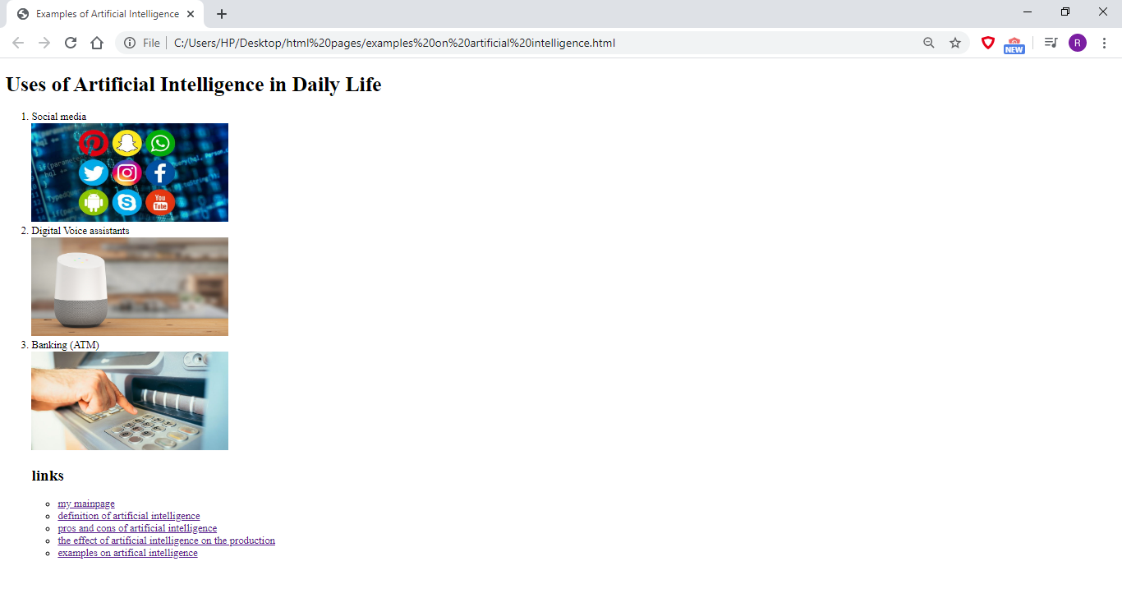

***Source code :***

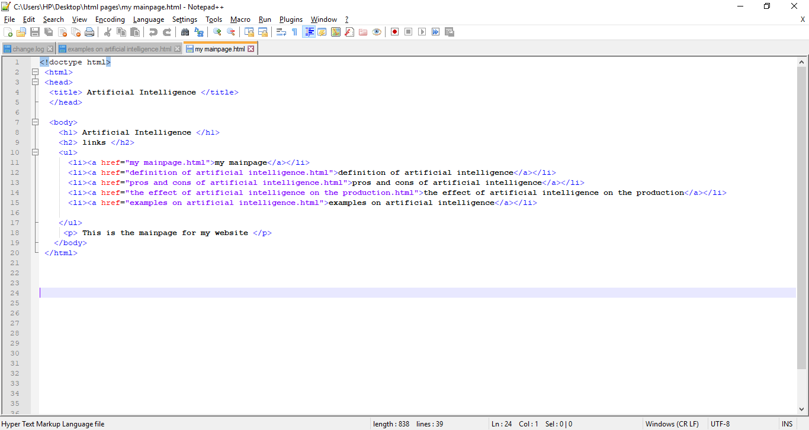

# Conclusions

On my opinion, I covered all the requirements of the research I created a mainpage and other four webpages .They contain lists , pictures,tables, and paragraphs that explain the artificial intelligence and its importance.

# References

<http://www.eolss.net/sample-chapters/c15/E6-44.pdf>

<https://www.researchgate.net/publication/335279198_On_Defining_Artificial_Intelligence>

<https://www.semanticscholar.org/paper/A-Definition-of-Artificial-Intelligence-Dobrev/5bd97fb4ce1b6ebf6be926a1e0512e1666cbe48b>

<https://builtin.com/artificial-intelligence>